**ECodex WebAdmin Guide**

Inhalt

Main Page 1

Monitoring panel 2

Connection panel 2

Jobs panel 2

Messages panel 2

Configuration Page 2

Monitoring panel 3

Job configuration panel 3

User configuration panel 3

Connector –Statistics 3

Gateway – Statistics 4

This document gives a brief overview over the functions of the ECodex WebAdmin GUI.

## Main Page

After login, you should find yourself on the main page, which shows the navigation menu on the left side and the summarized monitoring information in the center:

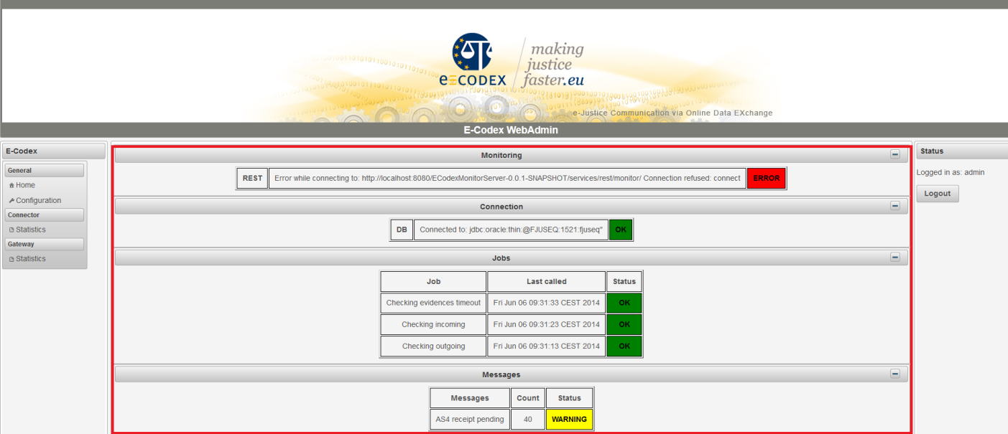

### Monitoring panel

The ECodex-Connector framework offers different interfaces to expose its monitoring information, namely JMX and REST. The monitoring panel shows the state of the selected monitoring type.

An ERROR is displayed, when the selected monitoring type is not reachable.

Note: When no monitoring interface is selected, the panel is not shown at all.

### Connection panel

This panel shows the information of the connected database.

### Jobs panel

This panel shows information about the regular running connector jobs.

### Messages panel

This panel shows the count of pending gateway messages.

## Configuration Page

The configuration page shows three panels for configuring different parts:

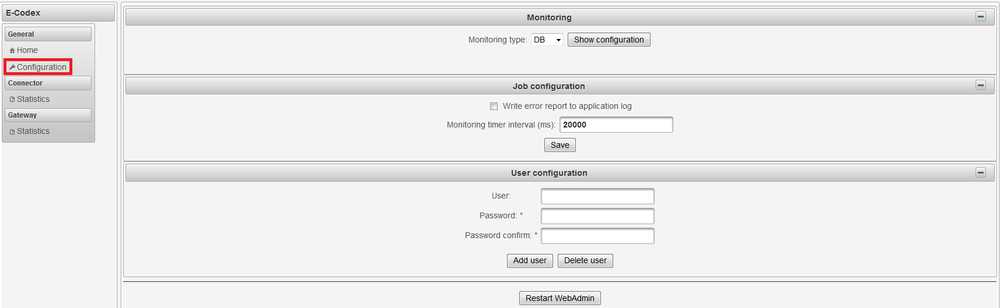

### Monitoring panel

This is the source, where the WebAdmin queries its monitoring information.

Possible values are “DB”, “JMX” and “REST”.

Configuration for DB is planned for a later release. In the meantime it is only information to which database the WebAdmin is connected.

JMX and REST can be fully configured over the GUI. The “Test” button tests the provided parameters and “SAVE” stores the information.

### Job configuration panel

Defines the time interval in which monitoring information is checked by the WebAdmin. In case of WARNING/ERROR a report is written to the application log.

### User configuration panel

This is a panel to add and delete users. To delete or add a user, you must first enter the necessary field’s username and password.

## Connector –Statistics

There are two options to choose from the drop down menu:

**Summary:**

Tis page Shows simple diagrams for overall data. At the actual state it shows the amount of incoming/outgoing messages and the type of service.

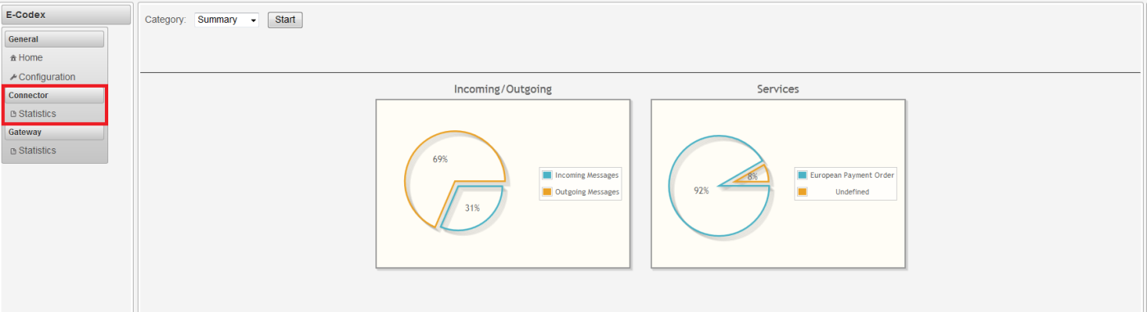

**Custom:**

Here, the connector message can be filtered by different parameters. By hitting the generate button, the result is displayed in the table below.

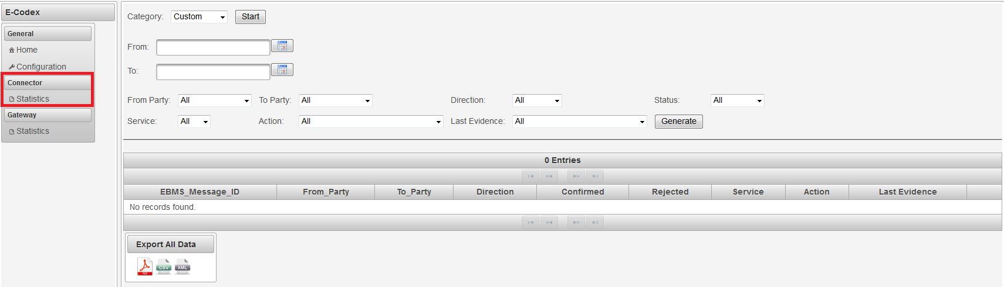

The loupe symbol in each row shows the evidence history.



The table data can be exported in the formats: PDF, CSV and XML by clicking the appropriate icon under the table.

### Gateway – Statistics

The buildup of the gateway statistic site is similar to the connector site.

